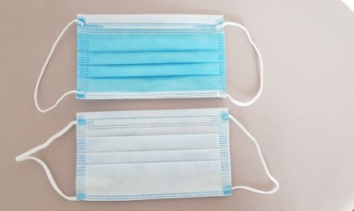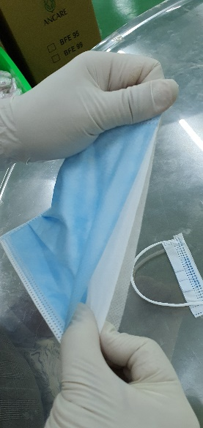

**Product specifications**

3 layer medical mask – can be used as non-medical product – non sterile

Layer 1 Non woven fabric (35 gsm)

Layer 2 Meltblown fabric (25 gsm)

Layer 3 Non woven fabric (35 gsm)

Size 17.5 cm X 9.5 cm

Level 3 ASTM Type 11R (EN 14683)

BFE 99%

Certifications : FDA, CE, ISO, TUV Test report, CFS, TGA

Packaging 10 pcs/polybag – 5 bags in box – 50 pcs. 50 boxes/1 carton

FOB price (Vietnam) USD 4.5/box

USD 225/carton

PRODUCT CODE– ACM3L99 : 3 PLY FACE MASK